DIVE MANAGER

User Guide

Table of Contents

1. Introduction 1
2. Launching the Application 2
3. Using the Main Menu 2
4. LOGIN 3
5. Dashboard 4
6. ResourceManagement............................................................................................................8
6.1 Create Service 8
6.2 Remove Service 9
6.3 Create Container 11
6.4 Start Container 11
6.5 Restart Container 11
6.6 Stop Container 12
6.7 Commit Container 12
6.8 Remove Container 12
6.9 Images 12
7. Project ..............................................................................................................................13
7.1 Create Project 13
7.1 Edit Project 13
7.2 Remove Project 13
8. Predictive Models 14
8.1 Upload PMML File 14
8.2 Remove PMML File 15
8.3 Deploy Model 15
8.4 Evaluate PMML Models 16
8.5 Undeploy Model 17
9. Lamda Models 18
9.1 Upload Model Diectory 18
9.2 Create Application 20
9.3 Train 21
9.4 Deploy 22
9.5 Evaluate 23
10. Jobs 24
10.1 Create Job 24
10.2 Remove Job 26
10.3 Create Schedule 26
10.4 Remove Schedule 27
10.5 Run History 28
11 Users
11.1 Create Users 28
11.2 Create Group 30
11.3 Remove User 30
11.4 Permission 26
11.5 Create Permission 31
11.6 Edit Permission 32
11.7 Remove Permission 33

1. Introduction
Dive Manager is application built using Spring MVC framework.

It helps in performing many

2. Launching the Application
To launch the application we need to launch browser.
Type the below URL.
http://dm.dywhin.com:8080/divemanager/login
Then choose the Menu option to display the required page.

3. Using the Main Menu
Choose one of the following options from the main menu:
Dashboard
Display grafana graphs for memory usage and Docker containers/services and images.
Project
Manager Project details.
Predictive Models
Deploying and Evaluating PMML models using open scoring service.
Lambda Model
Quickly build and deploy an engine as a web service in production with customizable templates.
Jobs
Create and scheduling jobs which nifi would pick on scheduled time and runs job.
Users
Handling LDAP user and groups and adding permission to the users.

4. LOGIN

Dive Manager is authenticated using LDAP. By default we need to have below two groups in LDAP.

- dn: cn=DIVEMANAGER_USER,ou=groups,dc=dywhin,dc=com
objectClass: groupOfUniqueNames
description: divemanager_user
cn: DIVEMANAGER_USER
uniqueMember: uid=dive_user,ou=users,dc=dywhin,dc=com

- dn: cn=DIVEMANAGER_ADMIN,ou=groups,dc=dywhin,dc=com
objectClass: groupOfUniqueNames
description: divemanager_admin
cn: DIVEMANAGER_ADMIN
uniqueMember: uid=dive_admin,ou=users,dc=dywhin,dc=com

- Click on below URL
http://dm.dywhin.com:8080/divemanager/login
- Below page to login credential displayed.

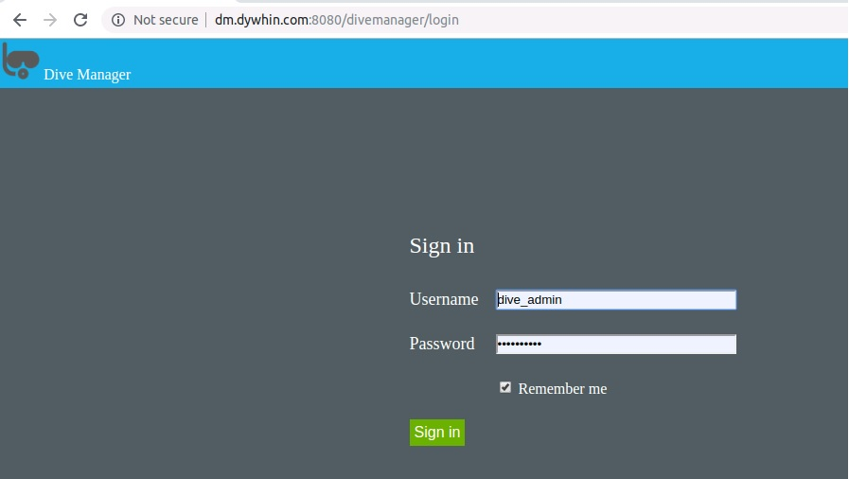

- Enter Username as dive_admin and password as dive@4275! Which is admin account.
- If success-full login home page of dive manager would be displayed.
- Depending on user role specific menus would be displayed.

5. Dashboard

Dive manager after logging in it would display dashboard page. It displays grafana graphs for memory usages of container. It display system details and also shows containers, services and images list.

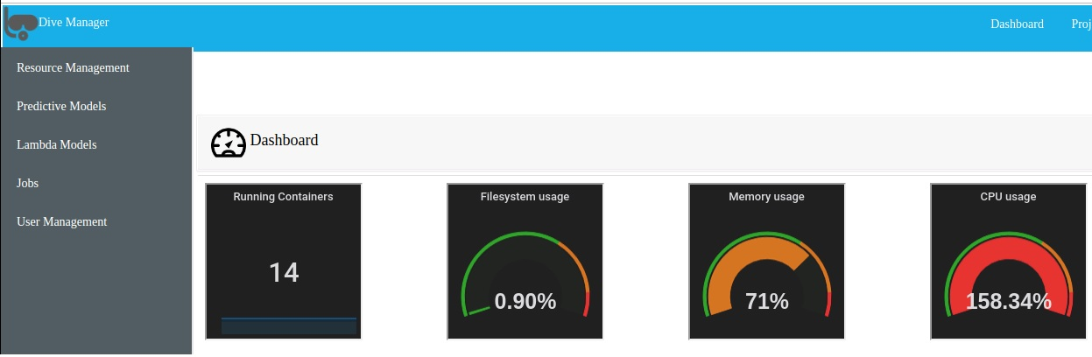

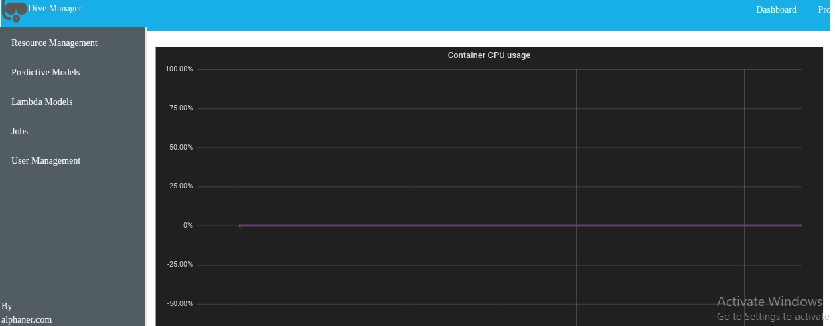

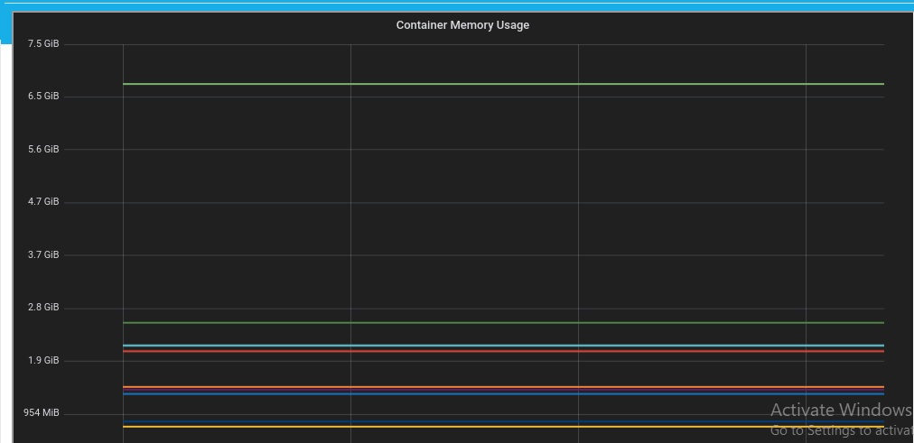

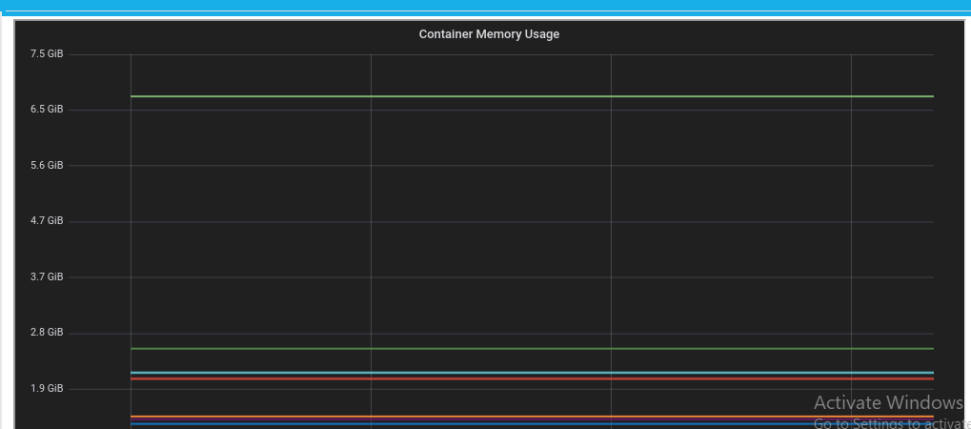

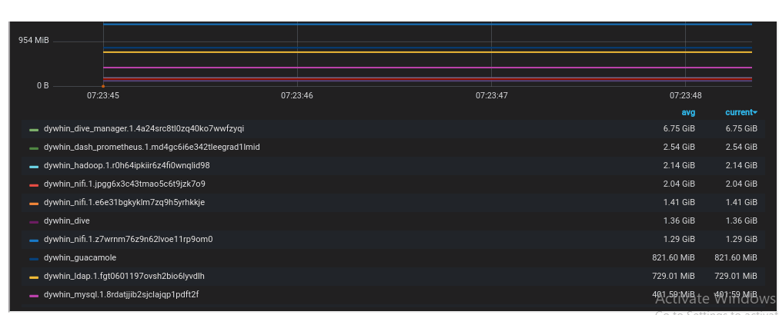

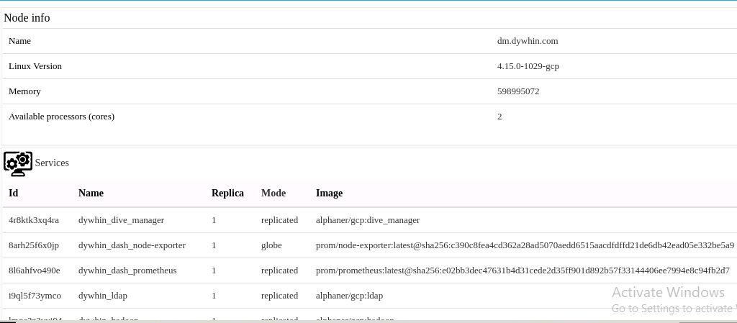

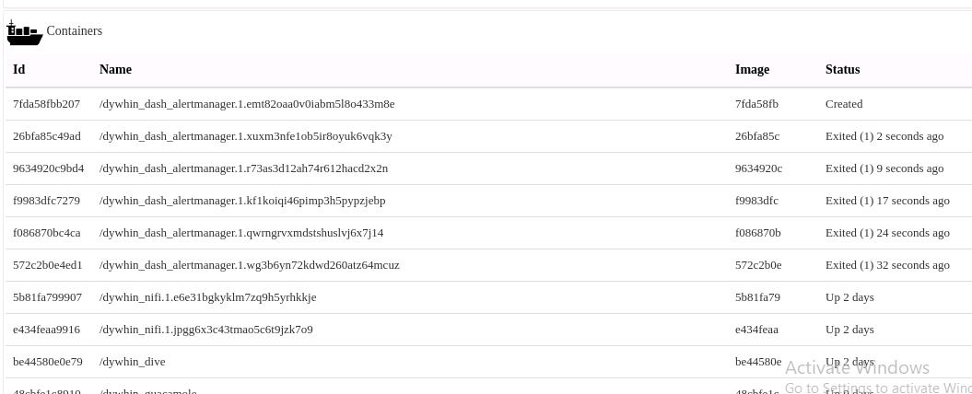

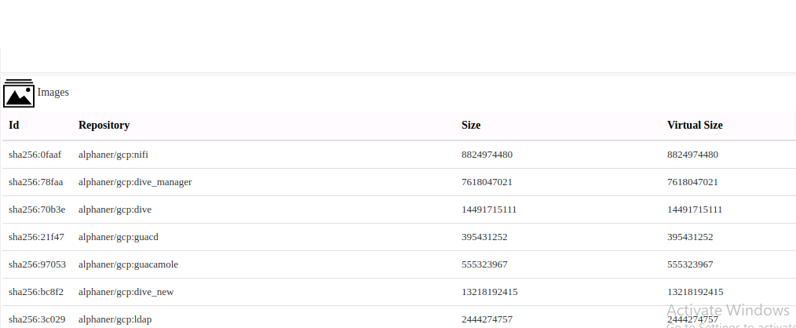

6. Resource Management

We can manage Docker containers, services and images.

6.1 Add Services

- Click on Menu “Resource Management” followed by sub menu Services.

- Services created for the system are displayed as shown below.

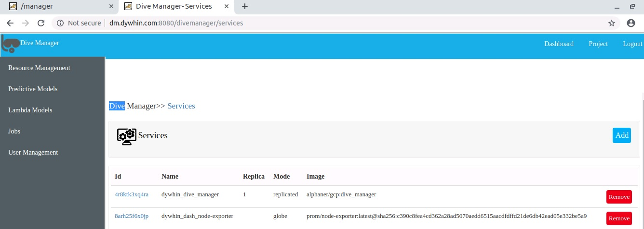
Figure. Services

- Click on button Add to create new Service. Below Add Service page would be displayed.

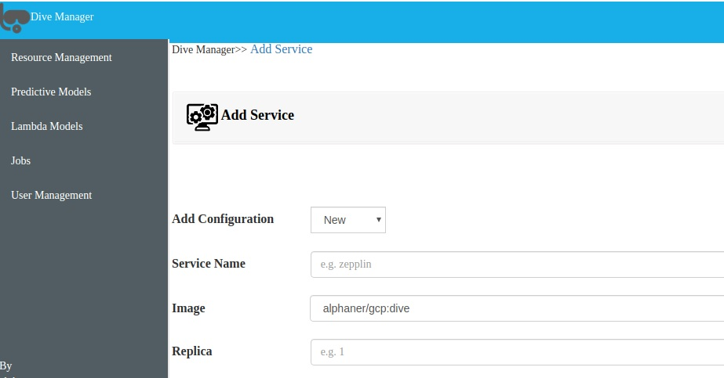
Figure. Add Service

- We have two options in Add Configuration New and Existing.
- If we select Existing then we get list of already created Services. We can select on them to import old setting.
- Enter Service Name and Replica and Select the image.
- Clicking on Service would create new Service.

6.2 Remove Services
- Click on Menu “Resource Management” followed by submenu “Services”.
- Services created would displayed as shown in above Figure. Services.
- Click on “Remove” button displayed for each service. Selected Service would be removed.

6.3 Create Container

- Click on Menu “Resource Management” followed by submenu “Containers”.
- All the containers created would be displayed as shown below

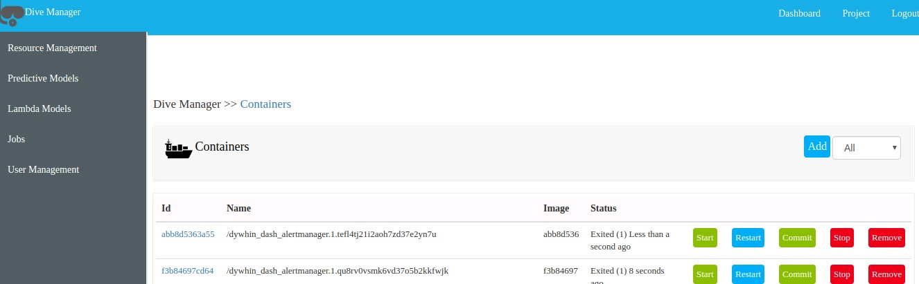
Figure. Containers

- Click on Add button which would display Add Container page show below.

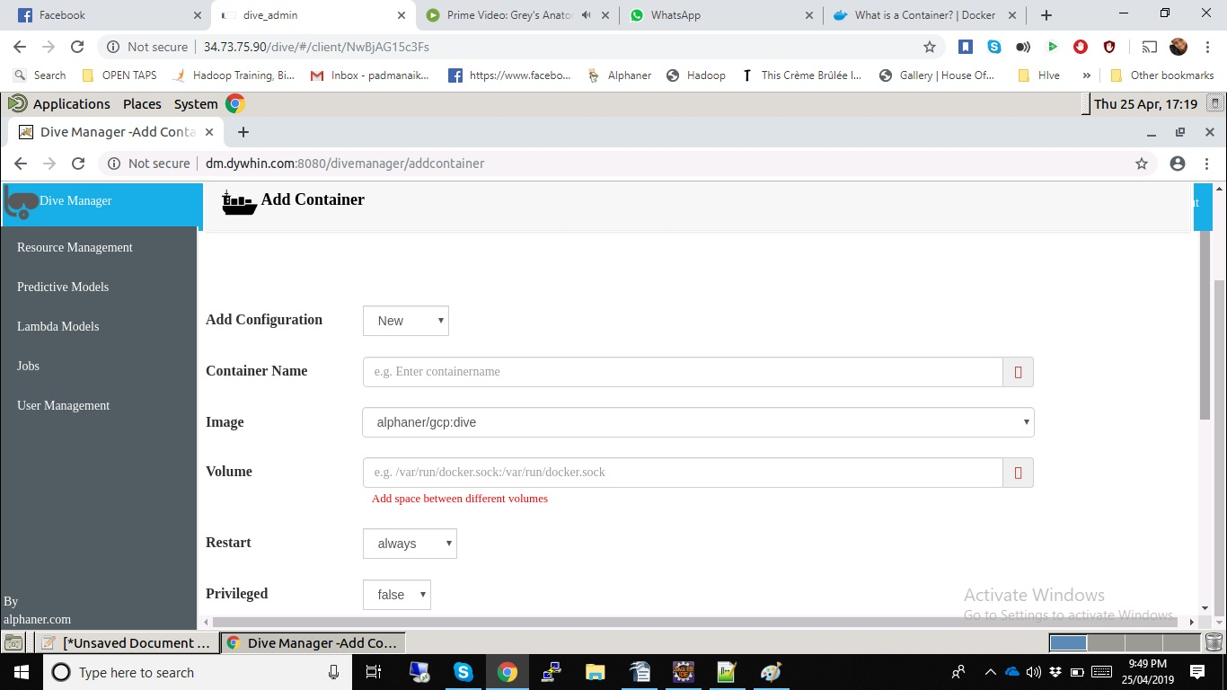
Figure. Add Container

- Select Add Configuration which contains New and Existing. If we select Existing it would display history of created Container.
- Enter container name and Select the image which we need add.
- We can enter multiple volume separate by space.
- Select Restart option which as “always”, “no” and “yes”.
- Select if it privileged.
- Clicking on save would create new container.

6.4 Start Container
- Click on Menu “Resource Management” followed by submenu “Container”.
- Services created would displayed as shown in above Figure. Services.
- Click on “Start” button displayed for each container.
- Selected container would be started.

6.5 Restart Container
- Click on Menu “Resource Management” followed by submenu “Container”.
- Services created would displayed as shown in above Figure. Containers.
- Click on “Restart” button displayed for each container.
- Selected container would be started.

6.6 Stop Container
- Click on Menu “Resource Management” followed by submenu “Container”.
- Services created would displayed as shown in above Figure. Containers.
- Click on “Stop” button displayed for each container.
- Selected container would be stopped.

6.7 Commit Container
- Click on Menu “Resource Management” followed by submenu “Container”.
- Services created would displayed as shown in above Figure. Containers.
- Click on “Commit” button displayed for each container.
- Selected container would be committed.

6.8 Remove Container
- Click on Menu “Resource Management” followed by submenu “Container”.
- Services created would displayed as shown in above Figure. Containers.
- Click on “Remove” button displayed for each container.
- Selected container would be removed.

6.9 Images
- Click on Menu “Resource Management” followed by submenu “Images”.
- Images created for the system would be displayed as shown below.
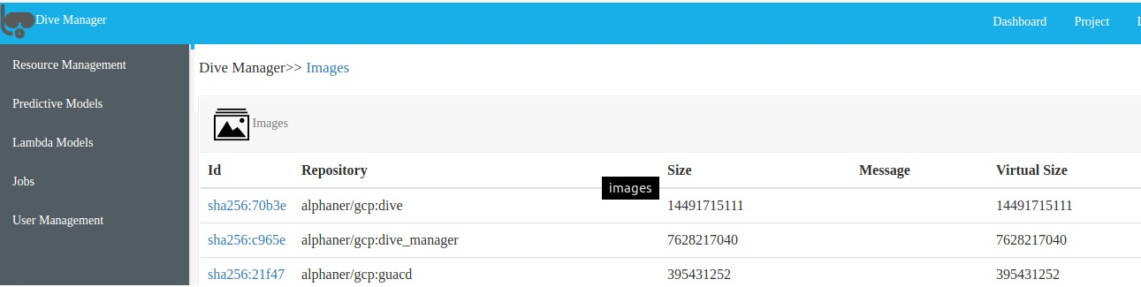
Figure. Images

7 Projects
We can manage to create/edit/delete project using dive manager.
7.1 Create Project
- Click on Projects menu from right side of the menu.
- A page of already created projects for logged in users are displayed.
- Click on Add button on the page and the below page is displayed.
- Enter user defined name for project and click on Save.
- Required project is created and displayed the projects page.

7.2 Edit Project
- Click on Projects menu from right side of the menu.
- Page of already created projects for logged in users are displayed
- Click on project id of the row which we need to edit.
- Edit project name and click update.
- Required project is updated and displayed the projects page.

7.3 Remove Project

- Click on Projects menu from right side of the menu.
- Page of already created projects for logged in users are displayed.
- Click on check boxes of the projects which we need to delete
- Click on button “Remove”. We get the confirmation box.
- Selected projects would be removed.

8. Predictive Models
- Discover a model.
- Load the data schema information of the selected model. Use this information to initialize bindings with data sources (active fields, group fields) and data sinks (target fields, output fields).
- Evaluate the selected model with data records.

8.1 Upload PMML File
- Click on Menu “Predictive Models” follows sub menu “Build”
- It would displays page with all the models created by logged in User.
- Click on Add menu it would display below page.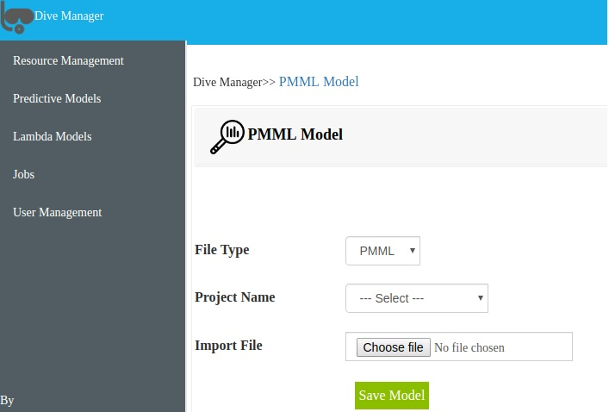
Figure. Upload PMML Models

- Select the Project Name which we need to add this Model.
- Select the PMML file which needs to be uploaded.
- Click on Save Model. New PMML Model would be uploaded and displayed in models page

8.2 Remove PMML File

- Click on Menu “Predictive Models” follows sub menu “Build”. It would display all models create by logged in users as below.
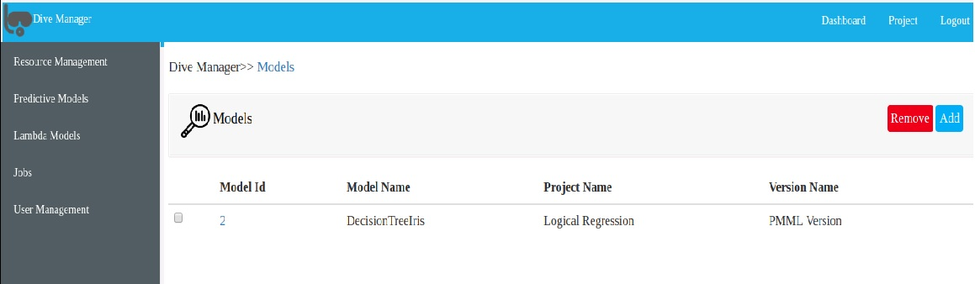
Figure. Remove PMML File

- It would displays page with all the models created by logged in User.
- Click on checkbox on each model which we need to remove. Click on “Remove” button.
- Confirmation box would be displayed. If clicking yes would remove all the PMML models uploaded.
Deploy Model

- Click on Menu “Predictive Models” follows sub menu “Deploy”.
- It would display all deployed models create by logged in users as below.
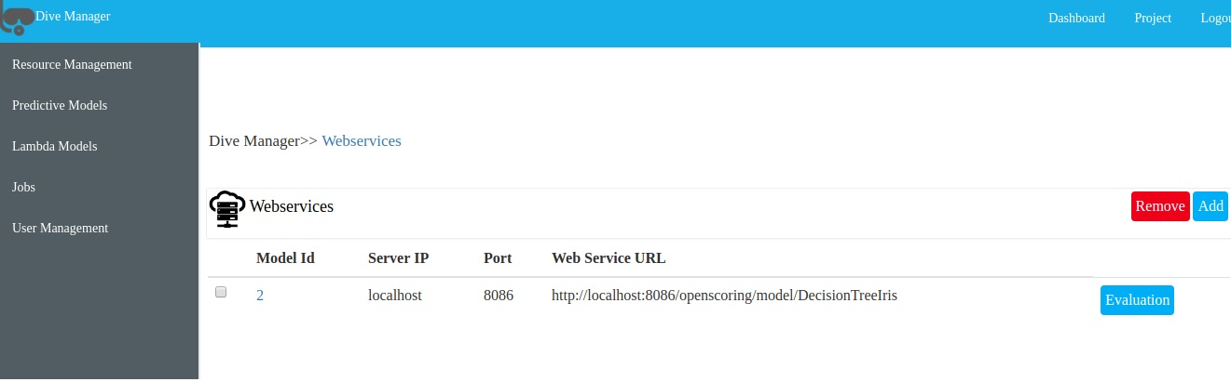
Figure. Deployed PMML Models

- Click on Add button. We get below page to deploy. We need to select Projects and model which we need to deploy

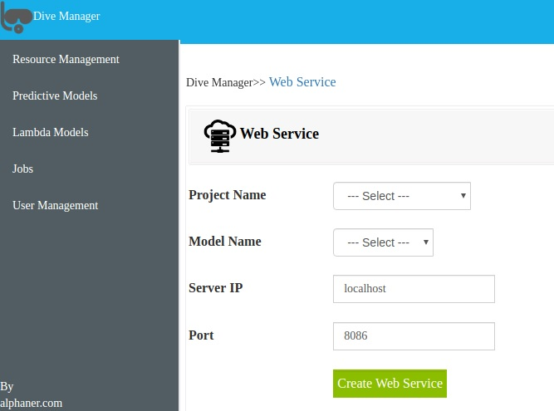
Figure. Deploy PMML Models
- Click on Create Web Service to deploy.

8.4 Evaluate PMML Models
- Click on Menu “Predictive Models” follows sub menu “Deploy”.
- It would display all deployed models creates by logged in users shown above as Figure Deployed Models.
- Click on “Evaluate” button. Below page would be displayed.
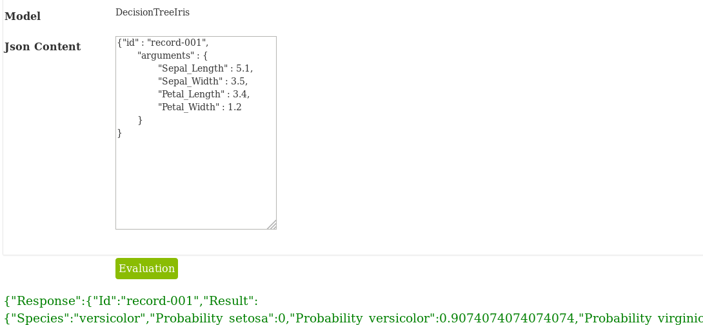

Fiqure. PMML Evaluation

- We need enter ”Json Content” for the Model as request.
- Model would be evaluated and Response would be sent back to user with the Result as shown in the above picture.

8.5 Undeploy Model
- Click on Menu “Predictive Models” follows sub menu “Deploy”.
- It would display all deployed models creates by logged in users shown above as Figure Deployed Models.
- Select all the check boxes to which we need to Undeploy
- Click on “Remove” button. Selected models would be undeployed.

9. Lambda Models
- Quickly build and deploy an engine as a web service in production with customizable templates
- Respond to dynamic queries in real time once deployed as a web service
- Evaluate and tune multiple engine variants systematically
9.1 Upload Model Directory
- Click on Menu “Lambda Models” follows sub menu “upload”.
- It would display below page to upload Model Client Directory.

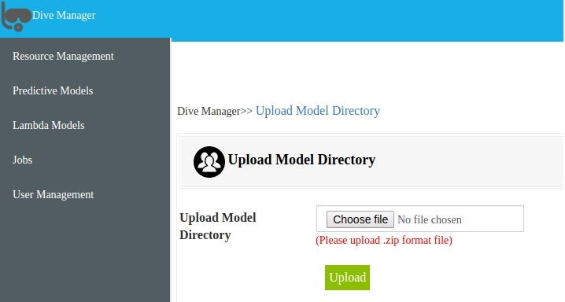Figure. Upload Model Directory

- We need to zip the directory to upload.
- For ex. predictionio.text.template.zip
- Before uploading we need add to Application Name in “engine.json” and other parameters if needed as show below as example.
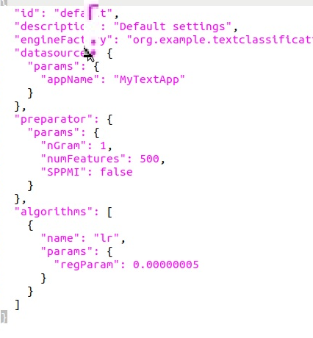
Figure. engine.json

- Add all the files to import in data folder.
- Ex
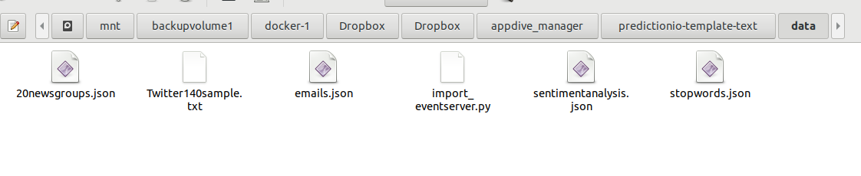

- Once all changes are done. Click on Upload,
- On Success Model Directory would be uploaded to server.
9.2 Create Application
- Click on Menu “Lambda Models” follows sub menu “build”.
- It would display application created bu logged in users as below.

- 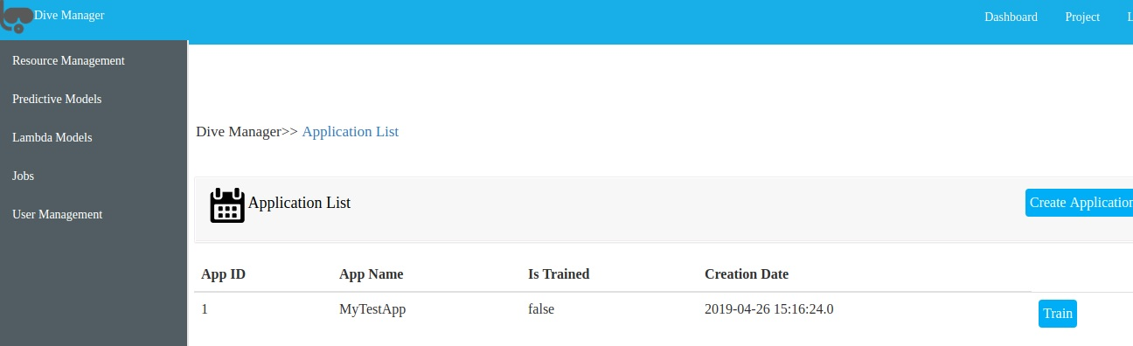

- Fiqure Build

- Create on button called “Create Application” if we need to create new application. After clicking below page would be displayed.

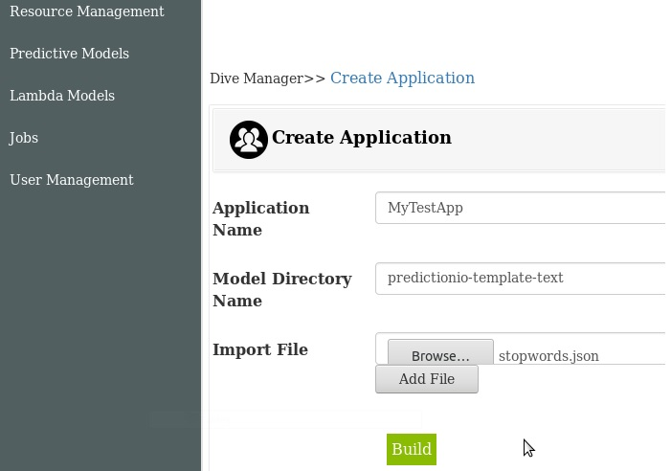
Figure. Create Application

- We need enter Application Name which is exactly same as the one which entered in “engine.json” as show in above Fiqure “engin.json”. It should be unique.
- Enter the model directory name same as the name zipped it while uploading.
- Import data files to import.
- File name to import should have same name as we uploaded.
- Click on Build.
- New application would created and data would be imported and It would build Model Directory.

9.3 Train
- Click on Menu “Lambda Models” follows sub menu “build”.
- It would display application created build list logged in users as shown above in Figure Build.
- Click on Train button. Below page would be displayed.
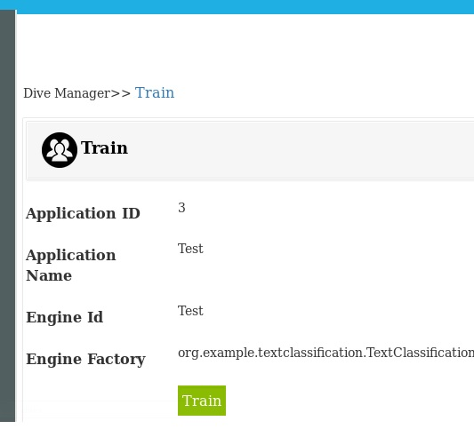
Figure. Train
- It would display the details created during creation of Application.
- Click on Train and it would start to train a predictive model with training data.
- Once the training is completed Engine Instance ID would be created and model is ready deploy.

9.4 Deploy

- Click on Menu “Lambda Models” follows sub menu “Deploy”.
- It would display trained applications which are ready deploy shown below which contains Engine Instance ID,Engine ID , Is it trained and Is deployed values.

- 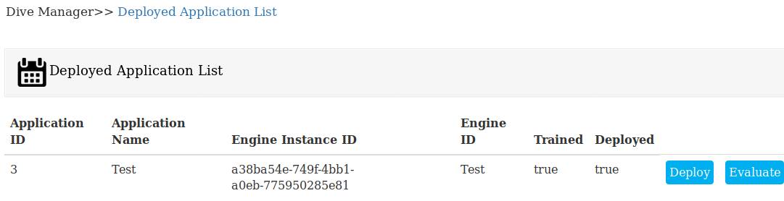
- Figure Deployed Application List

- Click Deploy button. Below page would be displayed.
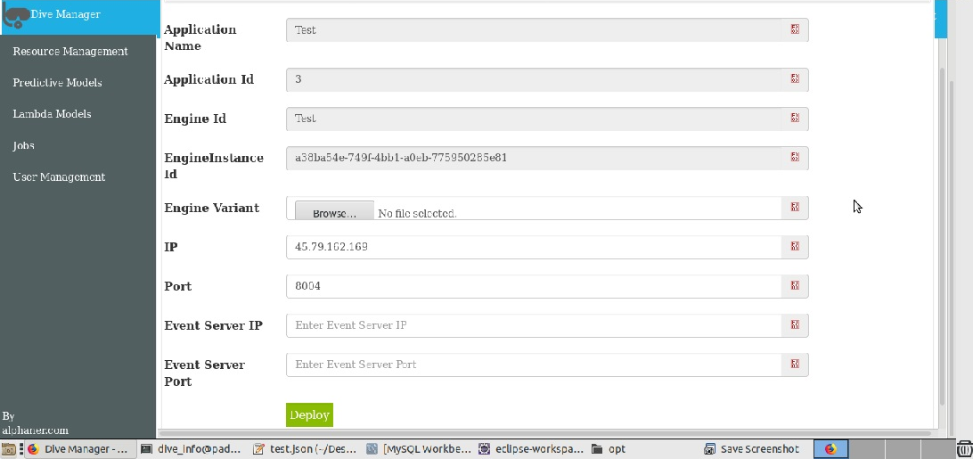
- Figure Deploy

- You can also specify the binding IP with --ip, which is set to localhost if not specified. For example: --ip 1.2.3.4
- By default, deploy deploys an engine on port 8000.
- You can specify another port with an --port argument. For example, to deploy on port 8123
- Clicking on Deploy would take the engine as a service.
- When the engine is deployed successfully and running. You can send query to the engine.

9.5 Evaluate

- Click on Menu “Lambda Models” follows sub menu “Deploy”.
- It would display applications ready to send the query to engine as shown in the above Figure Deployed Application List.
- Click on Evaluate button. Below page would be displayed.

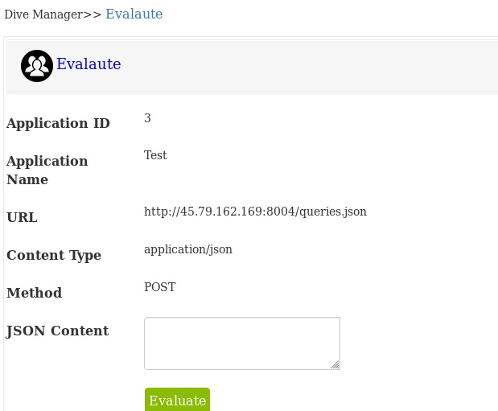
Figure Evaluation

- We would get response as below
{"category":"spam","confidence":0.5268770133242983}

JOBS
Jobs are created by Dive Manager and schedule by corn schedule and same picked by Nifi and run the jobs. After completion of jobs it would enter into run history.

Create Job
- Click on Menu “Jobs” follows sub menu “Create Job”.
- It would display jobs created by logged in user.

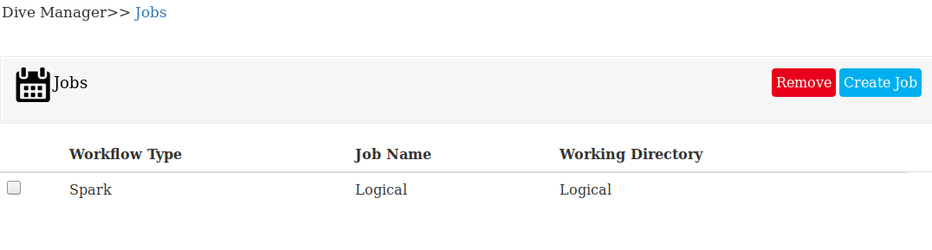
  - Figure Jobs

- Click on Create Job button. Below page would be displayed.
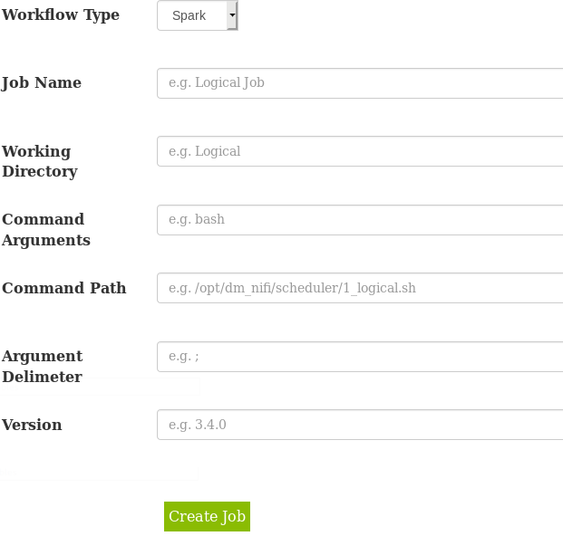
Figure Create Job
- We need to select from Workflow Type which as below three options
Spark
Shell
Python
- We need to enter our working directory ex “Logical Regression”
- Command Arguments would contain arguments like “bash”
- After schedule we create shell script in below path
- /opt/dm_nifi/scheduler/jobid_jobname.sh. We need to give the path name in Command Path.
- Argument delimiter would contain value like “;”.
- We need to give version for the job.

10.2 Remove Jobs
- Click on Menu Jobs followed by sub menu Create Job.
- It would display the page shown above as Figure Jobs.
- Click on checkbox to which the jobs to be deleted.
- Click on “Remove” button. Confirmation box would be displayed.
- On success it would delete all the jobs created.

10.3 Create Scheduler.
- Click on Jobs menu and followed by sub menu Create Scheduler.
- It would display all the scheduled jobs created by user show below.

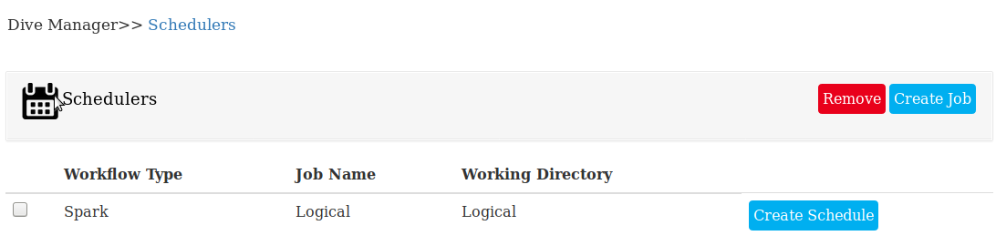
Figure Scheduler

  - Click on Create Schedule button. It would display below page.

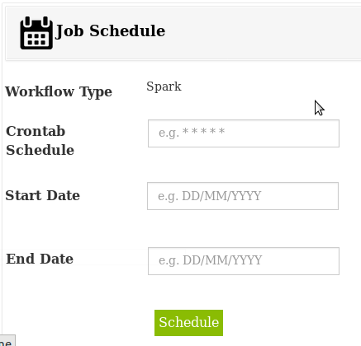
Figure Job Schedule

- We need to enter Corn tab Schedule for ex “0 1 0 0 0 ”.
- Enter Start date and End date.
- Once the Schedule completed the shell script with name having jobid_jobname.sh would be created in below path. /opt/dm_nifi/scheduler/1_Test.sh
- It would have below content
curl -X POST http://dywhin_nifi:9081/runjob/1_Test
- On scheduled corntab time nifi would run the job shown below.

10.4 Remove Scheduler
- Click on Menu Jobs followed by sub menu Create Scheduler.
- It would display the page shown above as Figure Schedulers.
- Click on checkbox to which the jobs to be deleted.
- Click on “Remove” button. Confirmation box would be displayed.
- On success it would delete all the schedulers created

10.5 Run History

- Click on Menu Jobs followed by sub menu Run History.
- After Nifi finishes the job it would enter the Job Run status into Run History.
- It would be displayed by Dive Manager shown below.

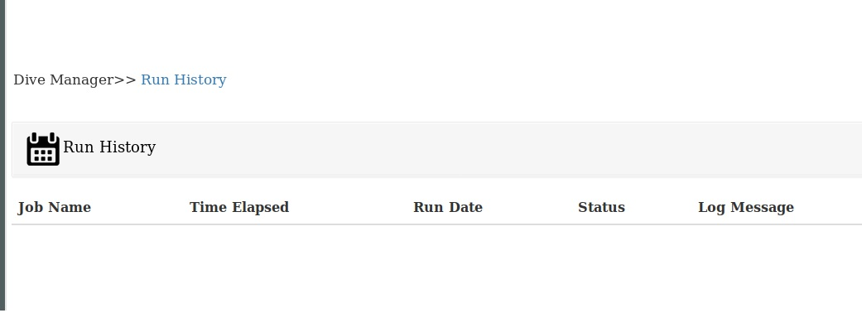
Figure Run History

Users Management
Dive Manager login authentication is handled by LDAP. We can manage LDAP using it.
11. 1 Create User

- Click on Menu User Management and Create User.
- Users created by logged in users would be displayed shown below.

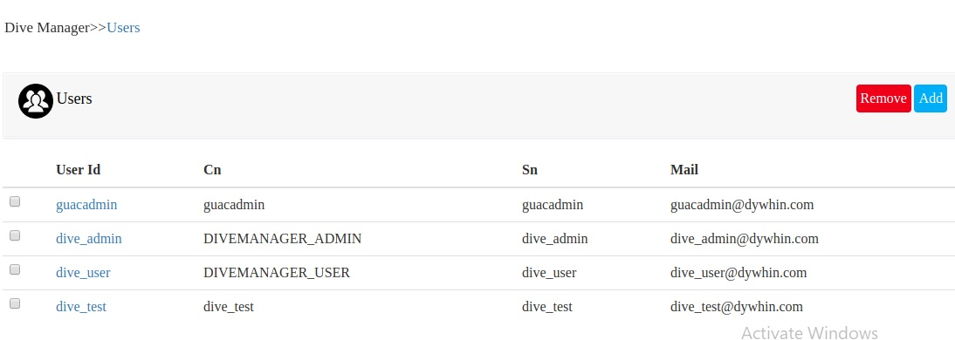
Figure Users

- Click on button Add. Below create user page would be displayed.

- 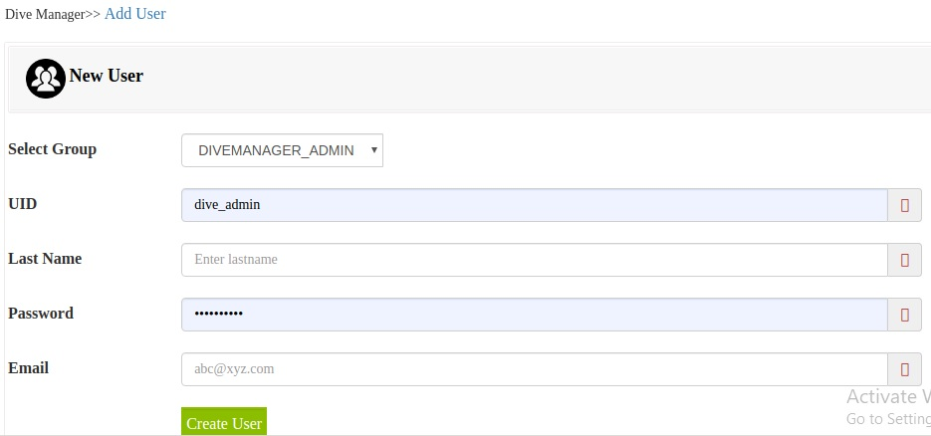

Figure. Create User

- We need to select which create group the user would be added.
- Enter UID or userid, last name ,password and email details.
- Click on Create User button. User would be created in ldap.

11.2 Create Group
- Click on menu User Management following sub menu Create Group.
- Below page would be displayed.
- 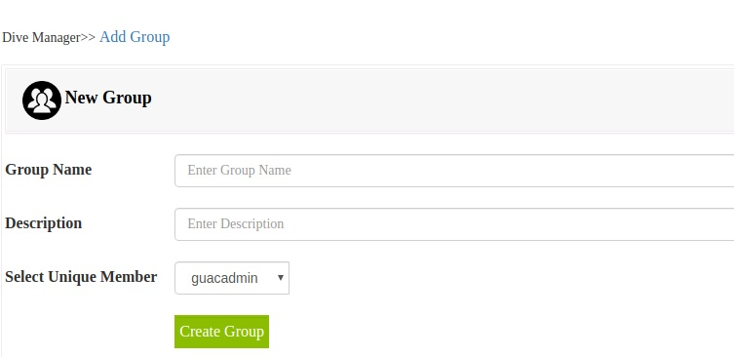
  - Figure Create Group

- We need to add group name and description for the same.
- Select unique member to add to the group. The selection box displays all the users create
- Click on Create Group button to create group.
- Group would be create and Figure Users would displayed.

11.3 Remove User/Group
- Click on menu User Management followed by sub menu Create User.
- Users page shown above in Figure Users would be displayed.
- Click on check box which you want to remove.
- Click and button Remove. Confirmation box would be displayed.
- On success selected users would be deleted from ldap.

11. 4 Create Permission
- Click on User Management menu followed by permission.

- 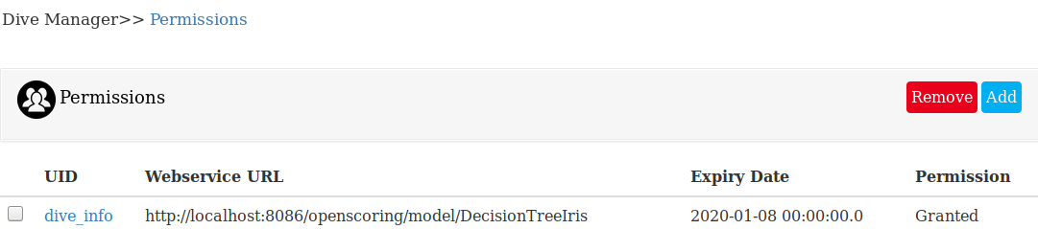
Figure. Permissions

- Clicking add button displays below page to add new permission.

- 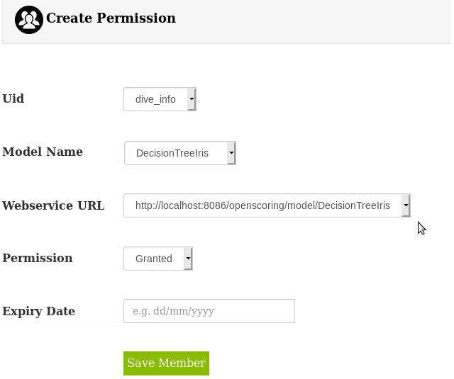

- Figure Create Permission

- Select User to provide permission to access web service.

- We need to select which model we need to provide permission to user.

- Select which Permission we need to give. It has Granted and Denied options.

- Enter expiry date to the same. Clicking on Save Member would create the permission.

11.6 Edit Permission

- Click on menu User Management and submenu Permissions.
- Permissions created by logged in users displayed show in above figure Permissions
- Click on Id which has link to edit page to permission shown as below.

  - 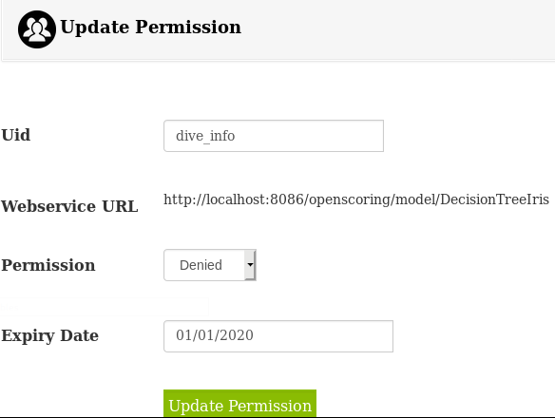
  - Figure Update Permission

- We can edit Permission value and click on Update Permission.
- Permission would be updated successfully.

11.7 Remove Permission
- Click on menu User Management followed by sub menu Permissions
- Page of permissions created by logged in show in above Figure Permissions.
- Select on checkboxes which we need delete. Click on Remove button.
- Confirmation box would be displayed.
- On success selected permission would be deleted.

